Plan View

186 m

0 m

320 m

FBP X

FBP Y

FBP Z

FCS X

FCS Y

FCS Z

Fire line

Road

320 m

160 m

10 m x10 m

2 m x2 m

300 m

250 m

150 m

100 m

50 m

Devices

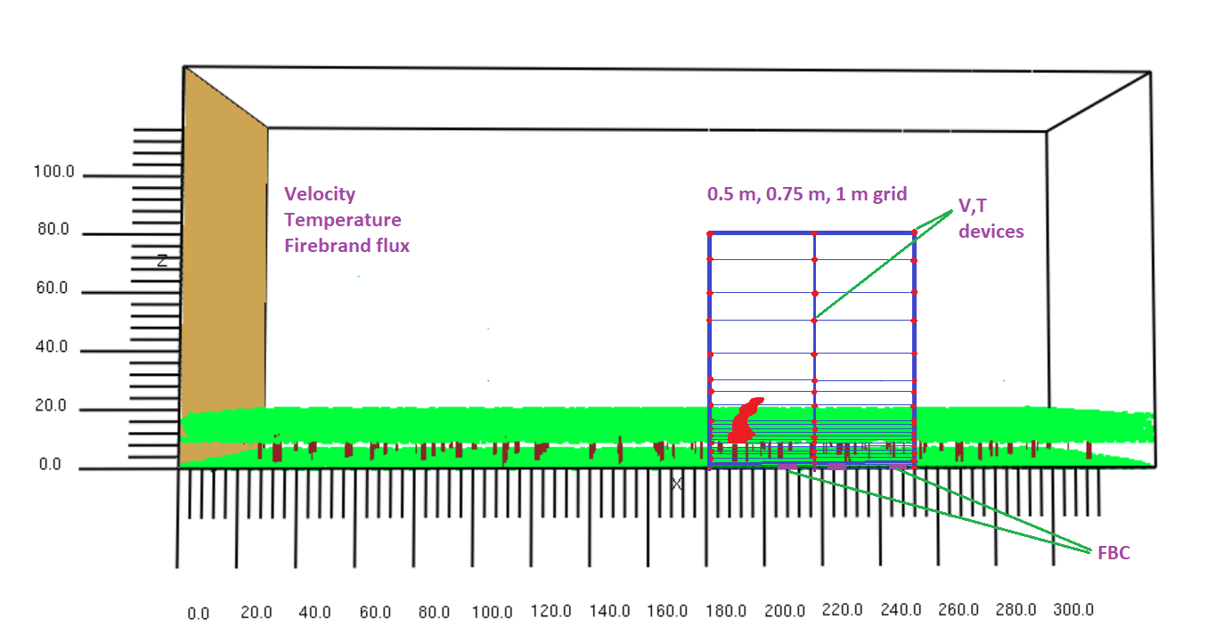

Firebrand flux

|  |  |  |
| --- | --- | --- |
|  | 750 mm grid  (pcs/m2s) | Experiment  (pcs/m2s) |
| FCS Z (closest to fire) | 1.0356 | 1.361 |
| FCS Y (middle location) | 0.3538 | 0.902 |
| FCS X (far away from fire) | 0.0408 | 0.824 |

Number of firebrands collected

|  |  |  |  |
| --- | --- | --- | --- |
|  | 750 mm grid  (pcs) | Experiment  (pcs) | Difference |
| FCS Z | 421 | 536 | 21% |
| FCS Z | 421 | 536 | 21% |
| FCS X | 16 | 335 | 95% |

750 mm grid firebrand flux (trial 1) inputting 7223 pcs/s

186 m

0 m

320 m

FBP X

FBP Y

FBP Z

FCS X

FCS Y

FCS Z

Fire line

Road

320 m

160 m

10 m x10 m

2 m x2 m

Firebrand flux according to size group